Project Report
On
EARLY LUNG CANCER DETECTION

Submitted by

AP23110011343 – M.Kalyani
AP23110011434 -K.TejaSree
AP23110011448 -G.Yamini
AP23110011462 -G.Mohana Krishna
AP23110011469 – R.Lohitha

BACHELOR OF TECHNOLOGY
IN
Computer Science and Engineering
School of Engineering and Sciences


Under the guidance of
Dr.Anila Makkapti

Department of Computer Science
SRM University AP,
Neerukonda, Mangalagiri, Guntur
Andhra Pradesh – 522240

S No. | Content | Page No.
1 | Title | 1
2 | Table Of Contents | 2
3 | Abstract | 3
4 | Introduction | 4
5 | Problem Statement | 5
6 | Objectives | 6
7 | Methodology | 7
8 | Tools and technologies used | 8, 9
9 | Dataset | 9
10 | System Design | 10, 11
11 | Implementation | 12
12 | Result | 13, 14
13 | Conclusion | 15
14 | Future Scope | 16
Table Of Contents
3. ABSTRACT

Lung cancer is one of the most serious health conditions and a leading cause of death worldwide. Early detection is very important for effective treatment, but it is often difficult because initial symptoms are not clearly visible. Traditional methods of analyzing CT scan images require expert knowledge, are time-consuming, and may sometimes lead to incorrect diagnosis. To address these challenges, this project presents an automated system for early lung cancer detection using Deep Learning techniques.

The proposed system uses a Convolutional Neural Network (CNN) to analyze lung CT scan images and classify them into three categories: Healthy, Benign, and Malignant. Before feeding the images into the model, preprocessing steps such as resizing and normalization are performed to improve accuracy and ensure consistency. The model is developed using TensorFlow and Keras, which provide efficient tools for training and prediction.

To enhance the interpretability of the model, Grad-CAM is used to generate heatmaps that highlight the important regions in the CT scan images. This helps in understanding how the model makes decisions and provides visual support for the prediction. In addition, a user-friendly web application is developed using Flask, where users can upload CT scan images and view the prediction results along with the heatmap.

The system aims to provide a fast, reliable, and easy-to-use solution for lung cancer detection. It can assist medical professionals in making better decisions and supports early diagnosis, which can ultimately improve patient outcomes.

4. INTRODUCTION

Lung cancer is a major health concern and one of the leading causes of death across the world. It develops when abnormal cells in the lungs grow uncontrollably and may spread to other parts of the body over time. Detecting this disease at an early stage is very important for successful treatment, but it is often difficult because the initial signs are not easily noticeable. In addition, medical images like CT scans are complex and require careful analysis.

In current medical practice, radiologists examine CT scan images manually to identify any abnormal patterns. Although this method is widely used, it demands significant expertise and time. As the number of patients increases, analyzing every scan becomes more challenging. Moreover, manual evaluation may sometimes result in differences in interpretation, which can affect the accuracy of diagnosis.

With the rapid development of Artificial Intelligence, especially Deep Learning, new approaches have emerged to improve medical image analysis. Convolutional Neural Networks (CNNs) are particularly effective in identifying patterns within images, as they can automatically learn important features without manual intervention. These capabilities make them suitable for detecting diseases from medical scans.

In this project, a Deep Learning-based system is designed to detect lung cancer from CT scan images. The system processes the input images, categorizes them into different classes, and generates visual outputs to explain the prediction. By integrating image processing techniques, machine learning models, and a web-based interface, the project provides a practical solution that can assist healthcare professionals in achieving faster and more consistent results.

5. PROBLEM DEFINITION

The detection of lung cancer at an early stage is a critical challenge in the medical field. CT scan images contain detailed information about lung structures, but analyzing these images manually is a complex and time-consuming process. It requires skilled radiologists to carefully examine each scan, which can lead to delays in diagnosis, especially when dealing with a large number of patients.

In addition, manual interpretation is subject to human limitations such as fatigue and variability in judgment, which may result in inaccurate or inconsistent diagnoses. Early-stage cancer is particularly difficult to identify because the abnormalities are often small and not easily distinguishable.

Therefore, there is a need for an automated and reliable system that can assist in analyzing CT scan images efficiently. Such a system should be capable of detecting lung cancer accurately, reducing the workload on medical professionals, and providing faster and more consistent results to support early diagnosis.

6. OBJECTIVES

The central aim of this work is to design and implement a dependable system capable of identifying lung cancer at an early stage through the analysis of CT scan images. The intention is to minimize reliance on manual interpretation while improving both speed and diagnostic precision.

To achieve this aim, the project focuses on the following objectives:
- To create an automated framework that processes and interprets lung CT scan images in an efficient manner
- To categorize the given images into three distinct classes, namely healthy, benign, and malignant, based on learned patterns
- To enhance the quality and consistency of input data through preprocessing operations such as resizing and normalization
- To develop and train a Convolutional Neural Network (CNN) model tailored for medical image classification tasks
- To incorporate Grad-CAM visualization in order to highlight the regions within the image that influence the model’s decision
- To build an interactive web-based interface using the Flask framework for smooth user interaction
- To present the prediction results in a clear and user-friendly format that can be easily interpreted
- To support medical practitioners by providing quicker insights that can aid in clinical decision-making

7. METHODOLOGY

The proposed system follows a step-by-step process to detect lung cancer from CT scan images. Each stage is designed to ensure accurate prediction and meaningful output.

• Data Collection
The dataset consists of lung CT scan images collected from publicly available medical sources. It includes normal, benign, and malignant cases for training the model.

• Image Preprocessing
All images are resized to 128×128 pixels for uniform input size. Pixel values are normalized to improve training performance and stability.

• Feature Learning using CNN
A Convolutional Neural Network (CNN) is used to automatically extract important image features. It learns patterns like edges, textures, and shapes from CT scans.

• Model Training and Classification
The CNN model is trained using labeled CT scan images to classify them into Healthy, Benign, and Malignant categories. It is implemented using TensorFlow and Keras.

• Visualization using Grad-CAM
Grad-CAM is used to generate heatmaps that highlight important regions in the image. This helps understand which areas influenced the model’s prediction.

• Result Display
The final output is displayed through a Flask web application. It shows the predicted class along with the original image and heatmap for easy interpretation.

8. TOOLS AND TECHNOLOGIES USED

The development of this project involves various tools and technologies for image processing, model building, visualization, and web application development. Each technology plays a specific role in building an efficient and complete system.

8.1 Programming Language
Python is used as the primary programming language for this project. It is widely preferred for machine learning and deep learning applications due to its simplicity, readability, and availability of powerful libraries.

8.2 Deep Learning Frameworks
- TensorFlow
- Keras
TensorFlow is used as the backend framework for building and training the deep learning model. Keras is a high-level API that simplifies the process of designing and implementing the Convolutional Neural Network (CNN). These frameworks help in efficient model training, testing, and prediction.

8.3 Image Processing Library
- OpenCV
OpenCV is used for handling and processing CT scan images. It is mainly used for image reading, resizing, and basic preprocessing operations required before feeding the images into the model.

8.4 Numerical Computing
- NumPy
NumPy is used for performing numerical operations on image data. Since images are represented as arrays, NumPy helps in efficient manipulation and processing of pixel values.

8.5 Data Visualization
- Matplotlib
- Seaborn
These libraries are used to visualize data and results. They help in plotting graphs such as training accuracy, loss curves, and displaying heatmaps for better understanding of model performance.

8.6 Web Framework
- Flask
Flask is used to develop the web application interface. It allows users to upload CT scan images and view prediction results easily. It connects the frontend with the backend model, making the system interactive and user-friendly.

8.7 Supporting Tools
- Jupyter Notebook / VS Code – for development and testing
- Web browser – for running the application interface

9. DATASET
The dataset used in this project consists of lung CT scan images categorized into the following classes:
- Adenocarcinoma
- Large Cell Carcinoma
- Squamous Cell Carcinoma
- Benign
- Malignant
- Normal
These labeled images are used to train and test the CNN model, enabling it to learn and identify patterns associated with different lung conditions.

10. SYSTEM DESIGN
The system design describes the overall structure and working of the proposed lung cancer detection system. It explains how different components interact to process the input image and generate the final result.
The system is designed as a sequence of steps where the user provides a CT scan image as input, and the system processes it through various stages such as preprocessing, model prediction, and visualization. Each module in the system performs a specific task to ensure accurate and efficient detection.

10.1 Architecture Diagram

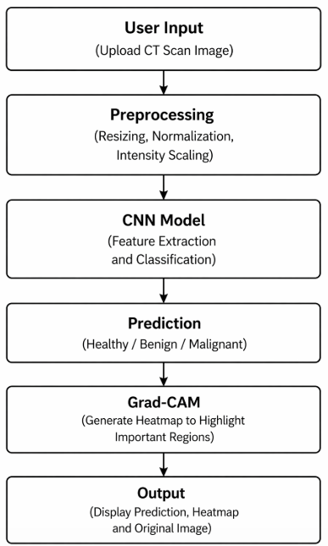

10.2 CNN Model Architecture

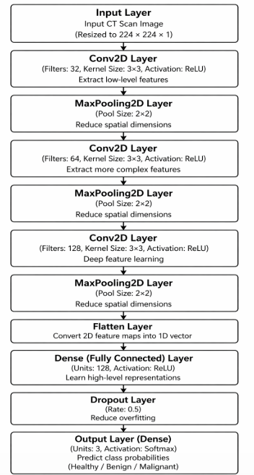

This architecture helps in extracting important features from CT scan images and classifying them accurately.

11. IMPLEMENTATION
- The system is developed using Python as the main programming language
- CT scan images are processed using OpenCV
  - Images are resized to a fixed size (128×128)
  - Pixel values are normalized for better performance
- The CNN model is built and trained using:
  - TensorFlow
  - Keras
- The model is trained on labeled CT scan images to learn patterns of:
  - Healthy
  - Benign
  - Malignant
- After training, the model is tested using separate test data to evaluate accuracy
- Visualization is performed using Matplotlib
  - Displays accuracy and loss graphs
  - Generates heatmaps using Grad-CAM
- A web application is developed using Flask
  - Allows users to upload CT scan images
  - Displays prediction results and heatmaps
- The trained model is integrated with the web interface for real-time prediction

12. Results

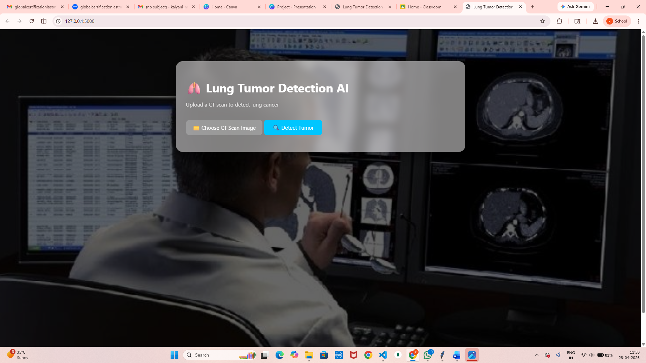

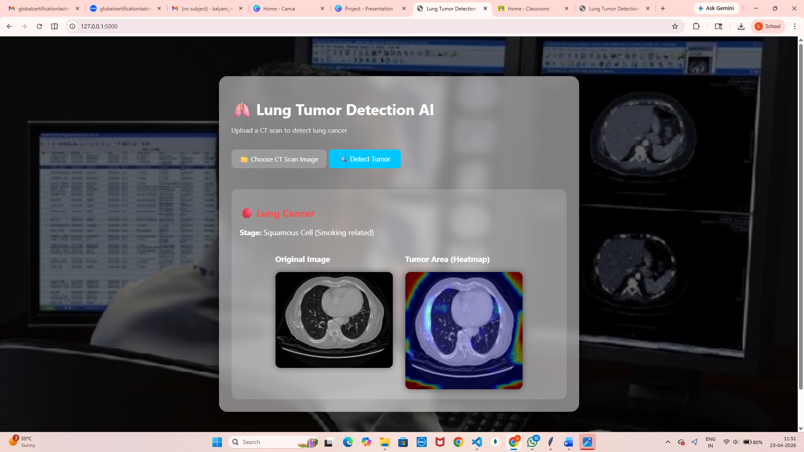

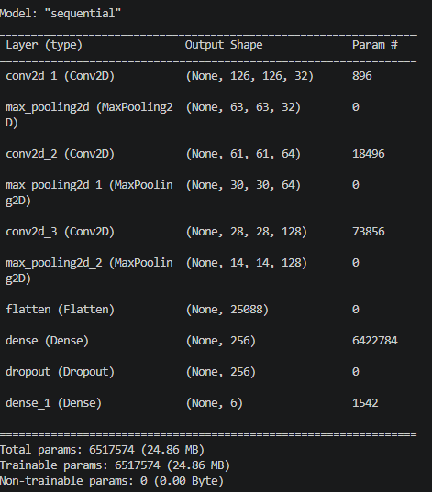

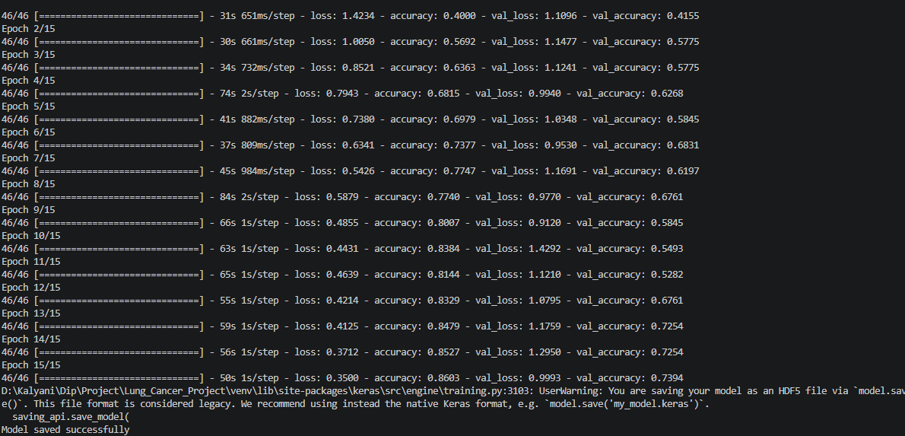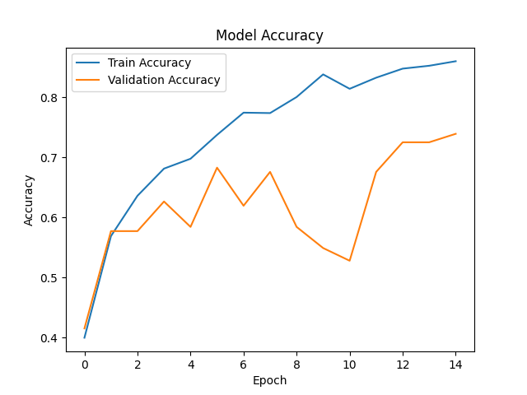

13. CONCLUSION

The proposed system demonstrates an effective approach for early detection of lung cancer using Deep Learning techniques. By utilizing a Convolutional Neural Network (CNN), the system is capable of analyzing CT scan images and accurately classifying them into Healthy, Benign, and Malignant categories. This reduces the dependency on manual analysis and helps in obtaining faster results.

One of the important aspects of this project is the use of image preprocessing techniques, which improve the quality and consistency of input data, leading to better model performance. In addition, the integration of Grad-CAM provides visual interpretation by highlighting the regions that influence the model’s prediction. This makes the system more transparent and easier to understand.

The development of a web-based interface using Flask further enhances usability by allowing users to upload images and view results in a simple and interactive manner. The combination of deep learning, image processing, and web technologies results in a complete and functional system.

Although the system shows promising results, it is intended to support medical professionals rather than replace them. With further improvements and access to larger datasets, the accuracy and reliability of the system can be enhanced.

In conclusion, this project provides a practical solution for lung cancer detection and demonstrates how Artificial Intelligence can be effectively applied in the healthcare domain to assist in early diagnosis and better decision-making.

14. FUTURE SCOPE

The proposed system provides a strong foundation for automated lung cancer detection; however, there are several areas where it can be further improved and expanded.

- The accuracy of the model can be enhanced by training it on larger and more diverse datasets, which include real-time clinical data from different sources
- Advanced deep learning techniques and architectures can be applied to improve performance and achieve more precise classification results
- The system can be extended to detect additional lung diseases, making it more useful in broader medical diagnosis
- A mobile or desktop application can be developed to make the system more accessible and convenient for users
- Integration with hospital management systems can enable real-time usage by doctors and healthcare professionals
- The model can be optimized for faster processing to support real-time analysis of CT scan images
- Additional features such as patient history tracking and report generation can be included to enhance usability

